**4 instances – 3grams files**

Run j-3JO6LDAS82MIF

Total key value pairs sent

With local aggregation: 735530 + 1253537 + 5 + 1029984 = 3019056

Without local aggregation: 29018786 + 1749226 + 645958 + 1103266 = 32517236

Run time: 19 minutes

Output: s3://my-bucket-mevuzarot-ass2-asd/output of run with 4 instances/

**2 instances – 3grams files**

Run j-3TDR2YE1HZ996

Total key value pairs sent

With local aggregation: 735530 +1163453 + 1 + 735506 = 2634490

Without local aggregation: 29018786 + 1749226 + 645958 +1103266 = 32517236

Run time: 34 minutes

Output: s3://my-bucket-mevuzarot-ass2-asd/output 3grams for 2 instances/

**4 instances custom input**

j-FFKW8N9A6QCK

With local aggregation: 82 +275 + 5 + 113 = 475

Without local aggregation: 82 + 287 + 164 +123 = 656

Run time: 8 mins

Output: s3://my-bucket-mevuzarot-ass2-asd/output custom input for 4 instances/

**2 instances custom input**

j-2I0EIIU97A7YB

With local aggregation: 82 +233 + 1 + 82 = 398

Without local aggregation: 82 + 287 + 164 +123 = 656

Run time: 7 mins

Output: s3://my-bucket-mevuzarot-ass2-asd/output custom input for 2 instances/

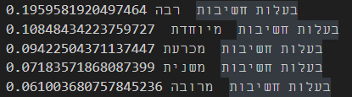

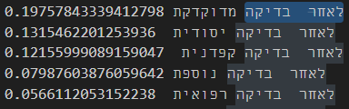

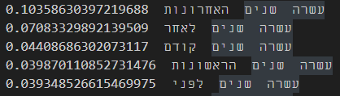

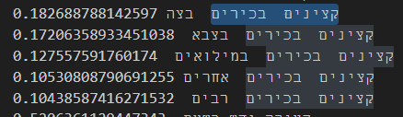

ניתן לראות שהמילים שהמילים המנובאות באמת הגיוניות.